**DEVELOP A WEB APPLICATION**

**USING NODE-RED SERVICE**

|  |  |
| --- | --- |
| **Date** | **19 November 2022** |
| **Team ID** | **PNT2022TMI36774** |
| **Project Name** | **Smart Solutions for Railways** |
| **Maximum Marks** | **8 Marks** |

**Node RED Design**

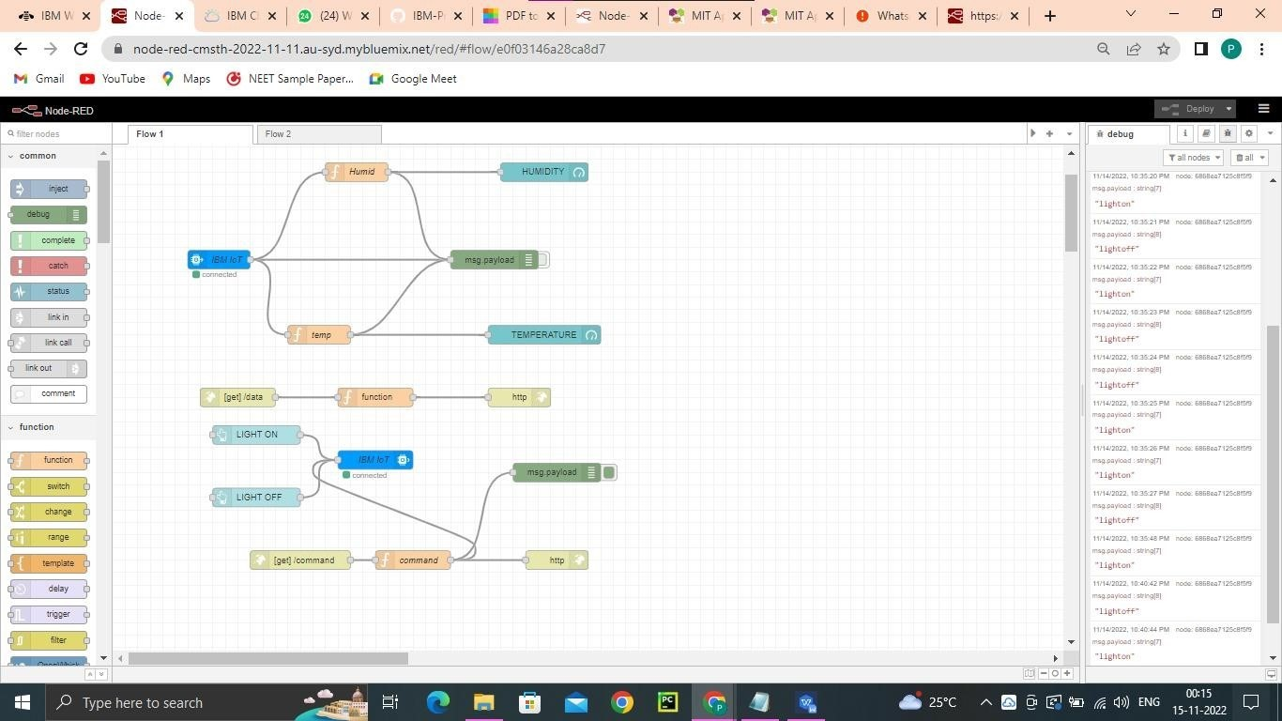

# Node RED WEBPAGE



